Parkland Communities
Your Guide To Parkland Homes For Sale
With a population of less than 30,000 people, Parkland is one of the most educated and affluent cities in Broward County. Over fifty percent of adults residing in Parkland FL possess a Bachelor’s degree or higher and the city is home to five “A” rated schools, including three elementary schools, a middle school and a high school.
If you are searching for a unique piece of Parkland real estate, you should know more about the many wonderful communities that are within the city limits. Learn special characteristics about each community by scrolling through the alphabetical list below and clicking on the link that peaks your interest:
Parkland Communities A-Z:
- BBB Ranches
- Country Acres
- Country Place
- Country Point Estates
- Cypress Cay
- Cypress Head
- Cypress Trail
- Fox Ridge
- Grand Cypress Estates
- Heron Bay
- In The Pines
- Lakes at Parkland
- Landings
- Mayfair
- Meadow Run
- Mews
- Parkland Estates
- Parkland Golf & Country Club
- Parkland Isles
- Parkland Reserve
- Parkside Estates
- Parkwood
- Pine Tree Estates
- Sable Pass
- Tall Pines
- Ternbridge
- Waters Edge
- Whittier Oaks

Coming Soon to the Wedge:
- Watercress at Parkland and Mira Lago

<Each of the above bullet point should be turned into a link that takes them to its specified paragraph below or a separate page>
BBB Ranches
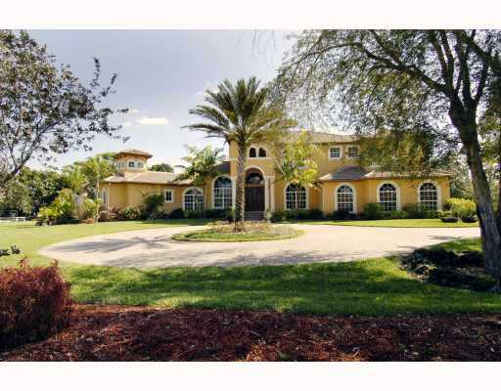
BBB Ranches is known as a community for equestrian lovers. These Parkland homes for sale are located north of Holmberg Road and offer majestic homes surrounded by lush landscapes. BBB Ranches is made up of 115 Single Family Homes, built on lot sizes between 1-5 acres and priced between $500,000 - $1.5M. Many residents have found their dream home/equestrian paradise in this neighborhood.
Country Acres
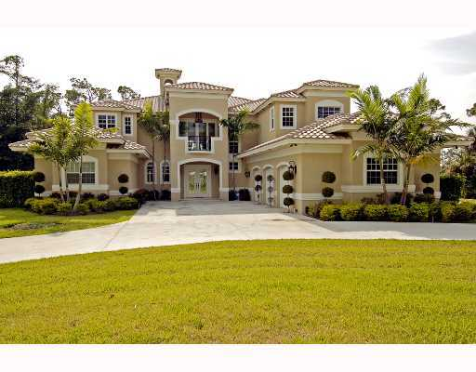
Zoned for both agricultural and equestrian living, Country Acres combines a luxurious country living setting with incredible custom built homes. Equestrian lovers and those with a green thumb will appreciate the lot sizes – between one and seven acres! Country Acres in Parkland FL is made up of spacious one and two story ranches and many of these homes include pools, guest houses and even tennis courts. For those residents who want to live in this area but have their own custom home in mind, sites are still available for building. If you are searching for your piece of Parkland real estate, there are currently 67 homes in this neighborhood and they are priced between $500,000 - $2M.
Country Place
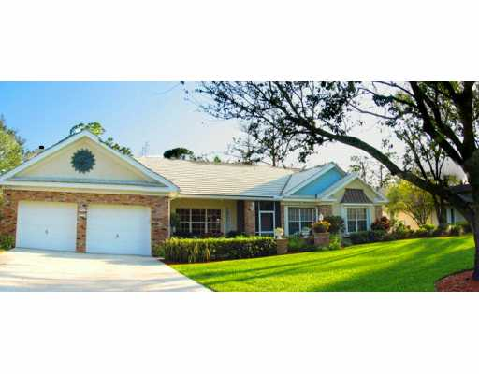
Country Place is a beautiful neighborhood of custom-built homes that sit on lots sized from ¼ acre to 1 acre. Serene landscapes fill this Parkland community that is situated between Coral Springs to the South and Boca Raton to the north. Prices in Country Place range between $300,000 - $1M.
Country Point Estates
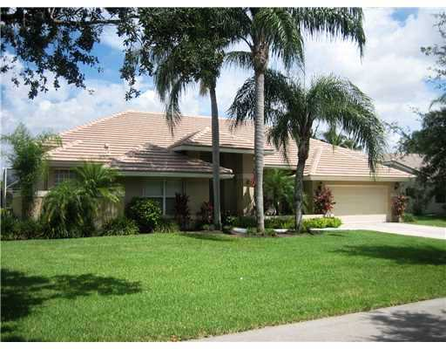
This community of Parkland homes boasts beautiful single family houses that sit on lots sized between ¼ acre and 1 acre. Many of the homes in this neighborhood offer lake views, pools, screened patios, two-car garages and volume ceilings. There are 152 homes in this area and there is a homeowners association/maintenance fee that includes the common areas. Country Point Estate prices range from $400,000 - $1M.
Cypress Cay
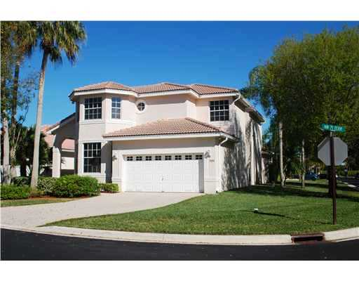
Welcome to country charm! Cypress Cay features one and two story homes containing anywhere from 3-5 bedrooms and living space up to 3,000 sq. feet. Close to city conveniences, Cypress Cay boasts a gated entrance, community pool, tennis court and the ability to take part in recreational activities at John H. Quigley Park. There are 103 single family homes in this Parkland neighborhood and it is within walking distance to Riverglades Elementary School. Homes in Cypress Cay vary between $200,000 - $600,000.
Cypress Head
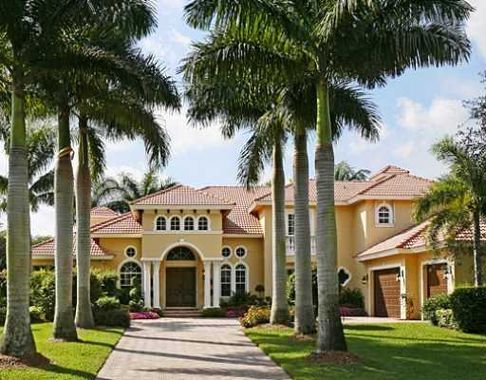
This impressive community offers residents spacious luxury homes built around a 62 acre lake, offering waterfront views, while also offering lavish landscape and wooded areas to homeowners. Facilities include a championship tennis area, large community pool, private clubhouses, and a large, inviting lake that is perfect for fishing and more. There are 448 single family homes in this Parkland neighborhood. This community of Parkland homes is priced between $450,000 - $2.5M.
Cypress Trail
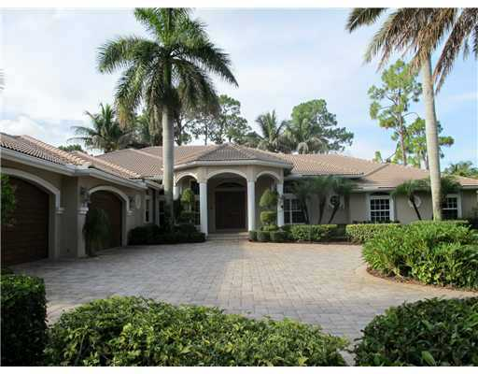

Welcome to the peaceful and exclusive gated community of Cypress Trail. With just 31 homes in this neighborhood, residents are met with beautiful spacious homes that are situated on ¾ acre lots. Nearby amenities for residents to enjoy include serene jogging trails and tennis. Prospective buyers in this Parkland neighborhood can expect to see prices from $500,000 - $1M.
Fox Ridge & Fox Ridge Estates
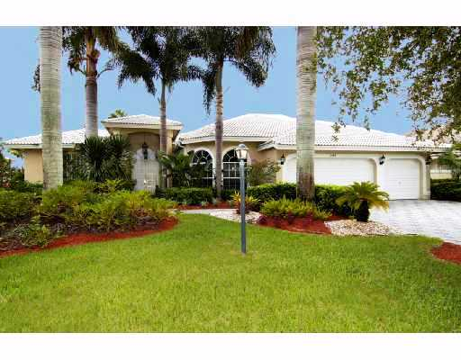
Fox Ridge features stunning homes that are situated on spacious lots, sized from ¼ acre to more than ¾ acre. This neighborhood offers winding waterways and even a private island with a variety of recreational activities for residents! Exclusive amenities available include tennis, playgrounds, jogging trails and picnic areas. There are 300 homes in this exclusive man-gated neighborhood. Parkland homes for sale in this community are priced from $400,000 - $1M.
Grand Cypress Estates
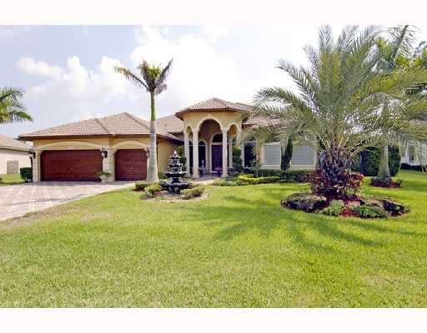
A magnificent neighborhood located in Parkland, Grand Cypress Estates offers 116 breathtaking homes that sit on lots sized from ½ acre and above. Residents enjoy the fact that this neighborhood is surrounded by natural lakes and cypress preserves in addition to parks, an equestrian center and a community tennis area. Prices in Grand Cypress Estates range between $600,000 - $1M.
Heron Bay
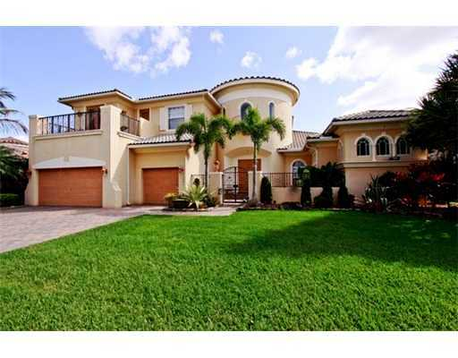
One of the award-winning Parkland real estate communities, Heron Bay is home to over two thousand luxury properties that are situated among stunning landscapes. This collection of homes features a wide variety of styles that appeal to any buyer – Caribbean, European and Mediterranean type homes. Sizes and types of homes vary also, as Heron Bay offers condos, townhomes, single family homes and extravagant estates. Amenities in this neighborhood include a championship 18-hole golf course, two resort-style pools, Jacuzzis, fitness center with spa, tennis courts, racquetball courts, basketball courts and a childrens water and play area. Homes in this collection range from $200,000 - $2M.
In The Pines
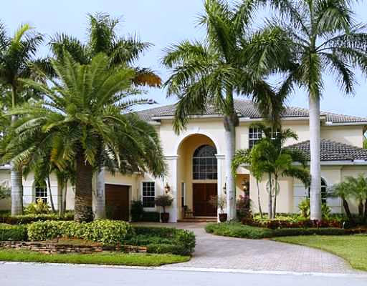
In The Pines is one of Parkland’s most exclusive gated communities - a small, intimate commune of just 17 luxury homes situated on 1/2 acre home sites. Most of these custom-built homes are two-story and feature anywhere from 5-7 bedrooms. Future buyers can expect to see prices in this community from $600,000 and up.
Lakes at Parkland (Parkland Lakes??)
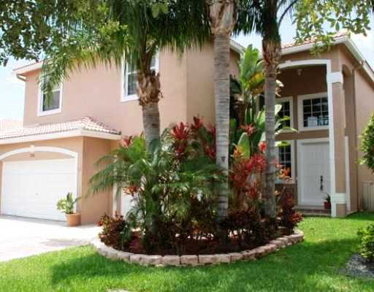
Welcome to the Lakes at Parkland, a quiet and friendly neighborhood where 89 out of the 116 properties offer relaxing lake views. Residents in this gated community have a variety of amenities available to them including convenient access to a 50-acre City Park. Potential buyers can expect Parkland homes in this neighborhood to be priced between $300,000 - $600,000.
Landings & Landings Estates
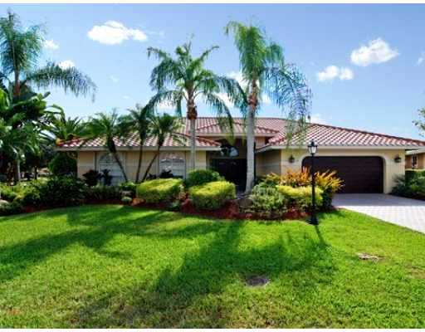
Once inside this private, gated community, residents are greeted by elegance, distinctive craftsmanship and the beauty of nature. The Landings is separated into two areas – The Landings and The Landings Estates. Amenities in these two communities include basketball and tennis courts, picnic area, volleyball courts and a playground. There are 251 homes in The Landings and they are situated on ¼ acre – ¾ acre sites. Parkland real estate in The Landings ranges from $400,000 - $1M.
Mayfair at Parkland
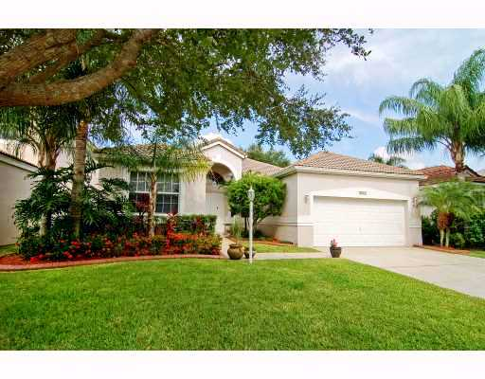
This affordable Parkland neighborhood offers residents one and two-story homes that feature 3-5 bedrooms. Many of the homes in this gated community have water views and they all are set upon lush landscapes. If you are a prospective buyer who is looking for the perfect single family home in a private and serene setting, then Mayfair might be the place for you! Prices in this community range from $300,000 - $600,000.
Meadow Run
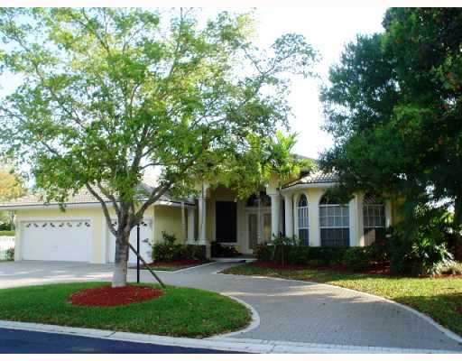
Meadow Run is a beautiful, private gated neighborhood that features one and two story homes. Most of the homes in this community have 4-6 bedrooms and spacious 3-car garages. Residents enjoy the natural, lush landscapes and peaceful environment that encompasses Meadow Run. Amenities include two gatehouses, tennis courts, play areas and pools with most homes. Buyers can own a piece of Parkland real estate in this area for only $400,000 - $800,000.
The Mews
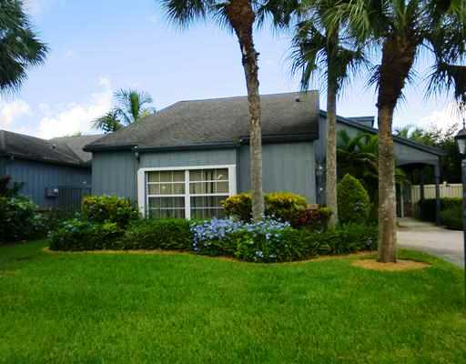
For buyers who are looking for something other than a single family home, The Mews might be for you. This adorable community offers one and two-story attached villas with up to 2,200 square feet of living space. Each villa varies between 2-4 bedrooms and a two-car garage. There are 76 properties in this neighborhood and resident amenities include a community tennis court and swimming pool. Villas are priced between $200,000 - $400,000.
Parkland Estates
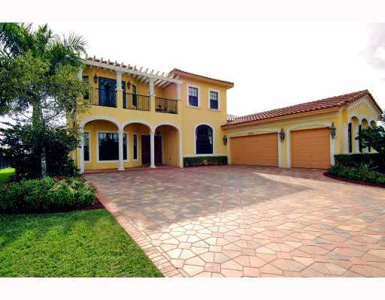
Welcome to the exquisite Parkland Estates - built by renowned home builder, Lennar Homes. This neighborhood is a one-of-a-kind collection with only 35 estate homes. Each home has a unique distinctive style ranging from Mediterranean, Tuscan and Italianate. Parkland Estates is a gated community featuring one and two-story homes with up to 6 bedrooms. If you are looking for a magnificent estate home, then this community of Parkland real estate might be exactly what you are looking for. Parkland Estates ranges in price from $600,000 - $1M.
Parkland Golf and Country Club
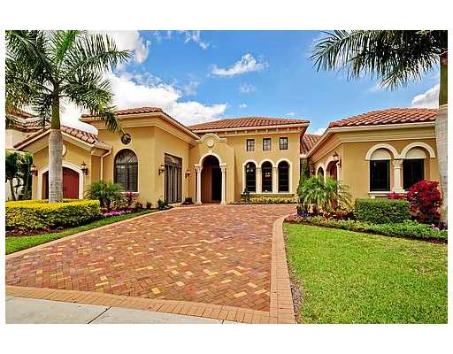
Parkland Golf and Country Club doesn’t just offer its residents a beautiful place to live, it also offers a lifestyle. This community provides top-notch amenities such as a Greg Norman designed championship golf course, spa, fitness center, tennis area, clubhouse, etc. There are over 800 properties in this neighborhood, including both single family homes and condos. Residents enjoy 24-hour security in this 790-acre lavish community. Parkland homes for sale in this area range from $250,000 - $3M.
Parkland Isle
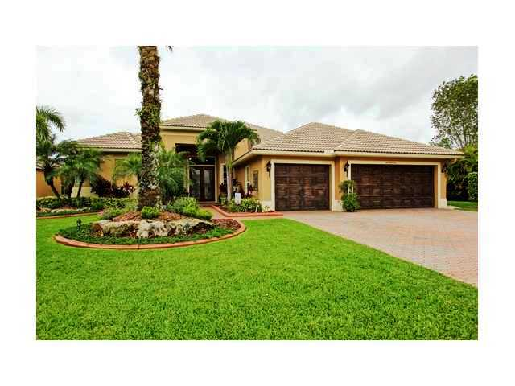
This man-gated neighborhood features homes with up to six bedrooms and 4,000 square feet of living space. Parkland Isles is surrounded by sparkling lakes and lush landscaping. Resident amenities include an exercise area, game room, tiki bar, spa, billiard area, heated swimming pool, clubhouse, tennis facilities and tot lot. Prospective buyers can expect prices in Parkland Isles in the range of $300,000 - $750,000.
Parkland Reserve
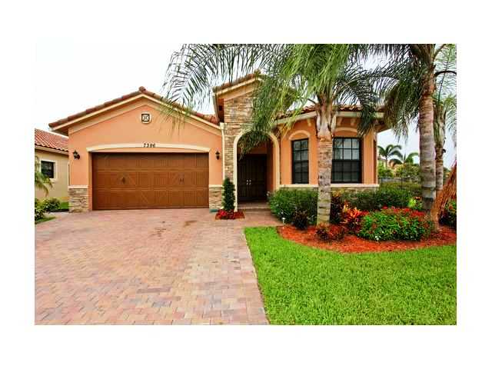
Parkland Reserve is a wonderful community filled with single family homes and townhomes and is just a short distance from top schools, shopping, dining and golfing areas. This neighborhood features three, four and five bedroom homes with up to 3,500 square feet of living space and three and four bedroom townhomes with oversized garages and hurricane impact windows. Built by prominent builder, Centerline Homes, this neighborhood is designed around four breathtaking lakes and is very affordable. These Parkland home prices range between $300,000 - $550,000.
Parkside Estates
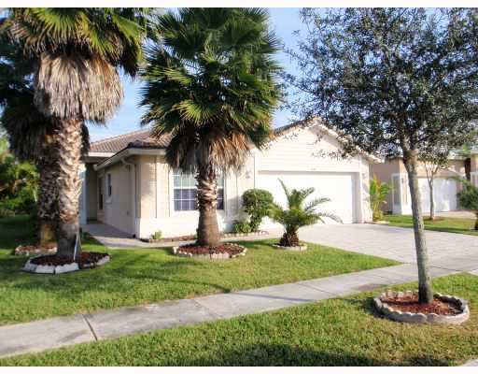
Located just in front of John H. Quigley Park, Parkside Estates offers residents one and two-story single family homes. Each home features up to five bedrooms and two-car garages. This neighborhood has an electronic gate entrance and offers residents a beautiful community pool, sundeck, BBQ area and childrens play area. There are 100 single family houses in this community and prices range between $250,000 - $400,000.
Parkwood
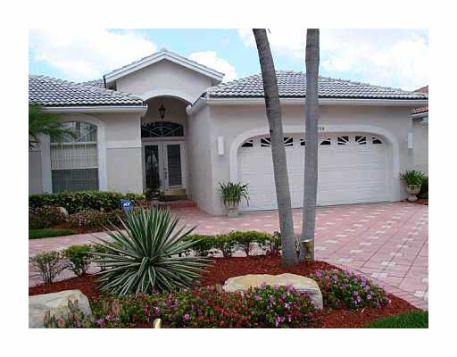
Parkwood is an adorable community of 126 one story homes with up to 2,600 square feet of living space and two or three car garages. Many of the homes here offer water views and private swimming pools and residents enjoy nearby sports and recreational activities at Terramar Park. Parkland home prices in this neighborhood range from $300,000 - $500,000.
Pine Tree Estates
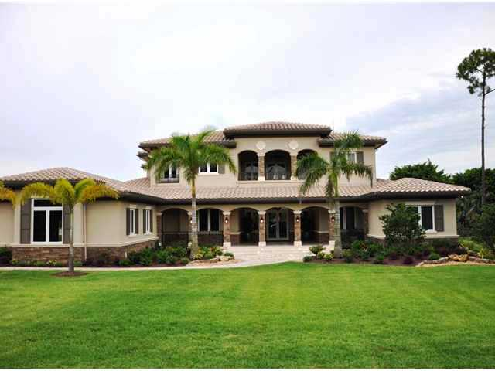
This prestigious neighborhood of 633 custom built homes is placed among a scenic country background where home lot sizes range from 1-3 acres. Housing styles include Ranch and also one and two-story estate homes. Many homes in this community feature pools, fireplaces, tennis courts, guest homes, barns and paddocks. Two added pluses to this neighborhood are: there is no formal homeowner association fees and home sites are still available for future building. Parkland real estate is available in this area for $400,000 - $3M.
Sable Pass
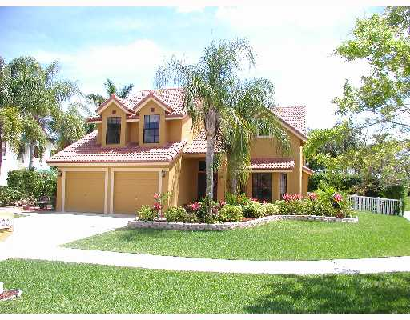
Sable Pass is a beautiful gated community that features 177 homes encompassing three to four bedrooms, two car garages and either one or two-story models. Many of the homes in this area offer water views and a private pool. Sable Pass is conveniently located near the Sawgrass Expressway, shopping and dining, and recreational facilities. Parkland real estate prices in Sable Pass range from $300,000 - $500,000.
Tall Pines
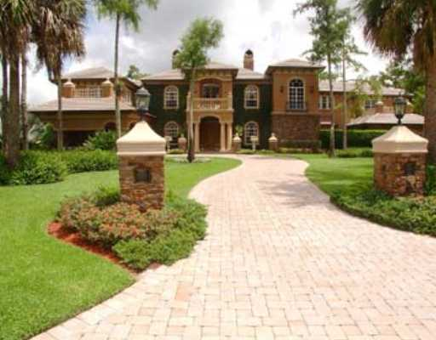
Tall Pines is one of Parkland’s most exclusive man-gated neighborhoods. Homes in Tall Pines are broken into two sections, with the larger one-acre homes sitting to the north and the half-acre homes located to the south. The community features natural greenery, serene landscapes, etc. There are over 100 homes in this area and prices range from $600,000 - $2M.
Ternbridge & Ternbridge Estates
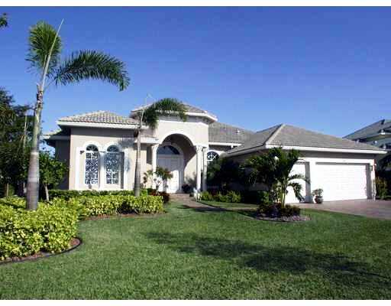
Another prestigious Parkland neighborhood, Ternbridge features single family homes that are accompanied by breathtaking water and tropical views. Amenities for residents include two tennis courts and a variety of recreational activities offered at Terramar Park. There are over 200 Parkland homes in this community and they are priced between $350,000 - $1M+.
Waters Edge
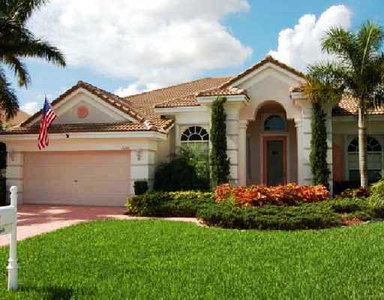
Surrounded by a 25-acre lake, the 44 homes of Waters Edge have become one of Parkland’s most desired places to live. These beautiful and spacious homes are located near the Sawgrass Expressway and offer an abundance of recreational activities. Waters Edge in Parkland is priced from $400,000 - $600,000.
Whittier Oaks
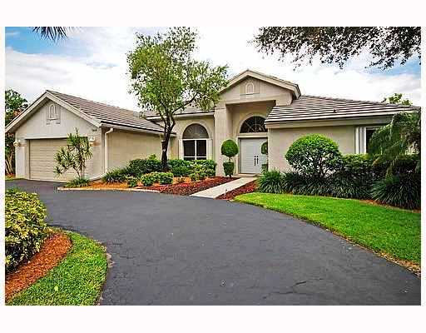
Residents in this neighborhood are within walking distance to a variety of parks and recreation. Parkland real estate in Whittier Oaks is priced between $300,000 - $600,000.

Parkland Homes Coming Soon:
Watercrest at Parkland
The newest community of Parkland homes currently under construction is Watercrest at Parkland. These 1-2 story single family homes (featuring 3-5 bedrooms) are described by builder Standard Pacific as a place where “every home will have a spectacular sunset and lake view.” There are 458 lots designed for this property site and they will be surrounded by over 150 acres of glistening lakes. To learn more about Watercrest at Parkland, contact Jon Klein at 954-415-5595.
Mira Lago
Another new community of Parkland homes currently being constructed by renowned builder Lennar is Mira Lago. This neighborhood will feature 1-2 story single family homes that offer up to 4,700 square feet of living space. There will be 526 homes in Mira Lago and buyers will have 12 distinctive home designs to choose from. Homes at Mira Lago will be surrounded by a 134 acre central lake. Learn more about this unique community of Parkland real estate – Call Jon Klein today!

